Thursday, November 11, 2010

A Veterans' Day Salute
by Glenn N. Holliman
U.S. Army, Vietnam 1969
A Thank You to our Veterans

I suspect our family members have been represented in our country's battles from Colonial Chesapeake to the 21st Century Middle Eastern Wars. As it is impossible to list all of them in any kind of complete listing, I will let my nephew, Capt. Jonathan Murphy, USA, take the salute for all who been on active duty, the Reserves or National Guard. Jonathan is on duty somewhere in Afghanistan, his second tour in four years. His family waits for him in the States.

For a time he was Captain of the Guard at the Tomb of the Unknown Soldier in Washington, DC. Below are two photographs - one of Jonathan leading his platoon up the steps of the Memorial and the second of him walking the Guard. For those of us who have stood on guard in other fields and seas, including my father, uncles, nephews and cousins, we express our appreciation to him and all relatives who have gone before him.
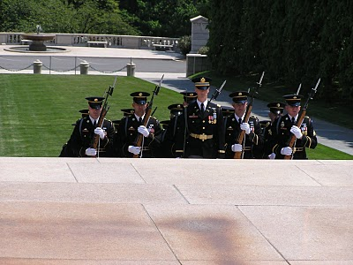
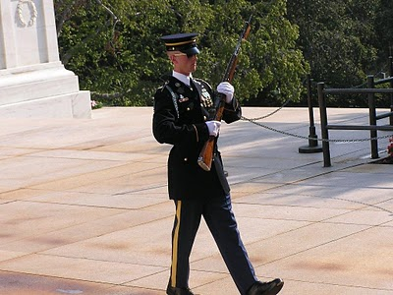
Among his ancestors are family members who served in the French and Indian War, Revolution, War of 1812, Civil War, World War II, Viet Nam, the Cold War and recent Middle East conflicts. One great grandfather, Luke Stansbery (1750 - 1848), was held as a prisoner of war of the British in Charleston, SC 1780 during the American Revolution.

